**ENGINEERING EXPLORATION**

# Mechanism Part A

Name: ESHAN KALP TRIVEDI

Roll no.:16010221038

The concept of mechanism was one of the most interesting topics I have learned till now in the course. Mechanisms are used for transforming input forces and motions into desired set of output forces and motions. When we keep different links fixed we get different kinds of motions. I got to understand different kinds of links namely binary, tertiary and quaternary links. Another concept that I understood is that of ‘Degree of freedom’. Most importantly doing the practical work was a good experience.

*Keeping the first link fixed.*

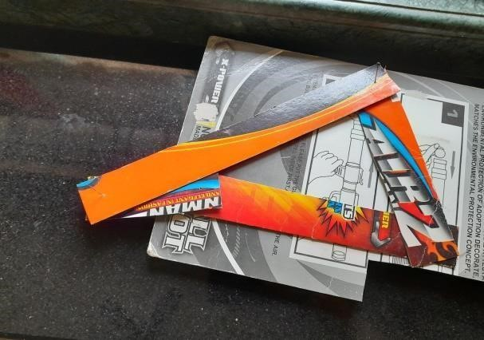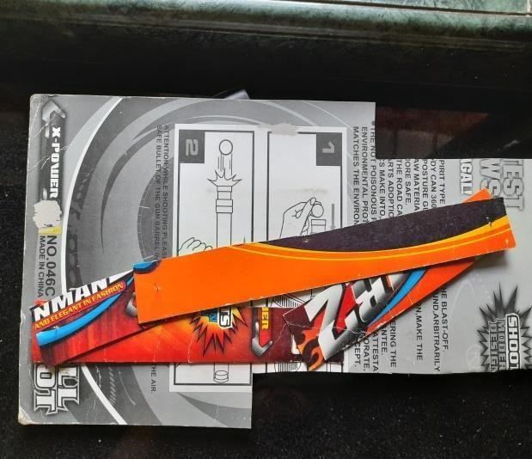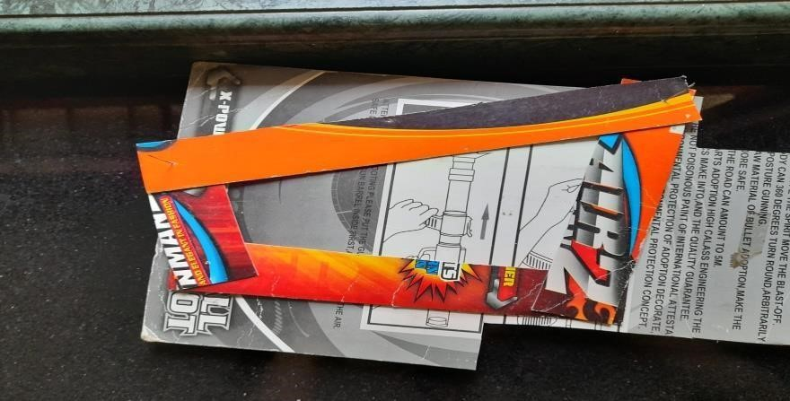

*Keeping the second link fixed.*

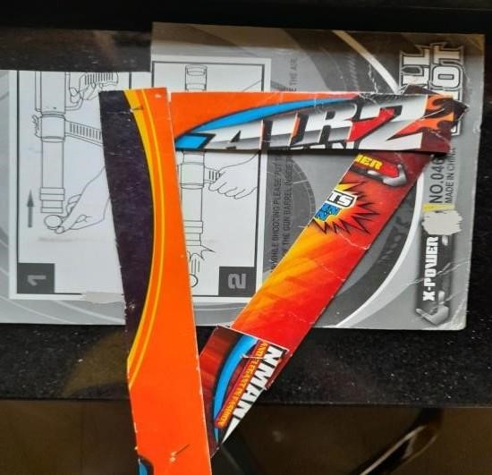

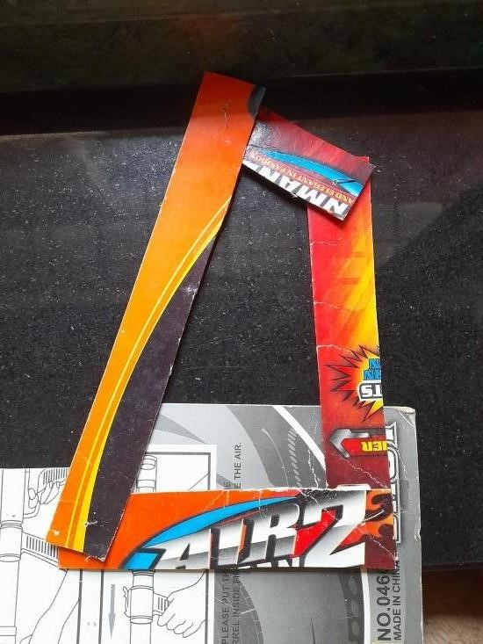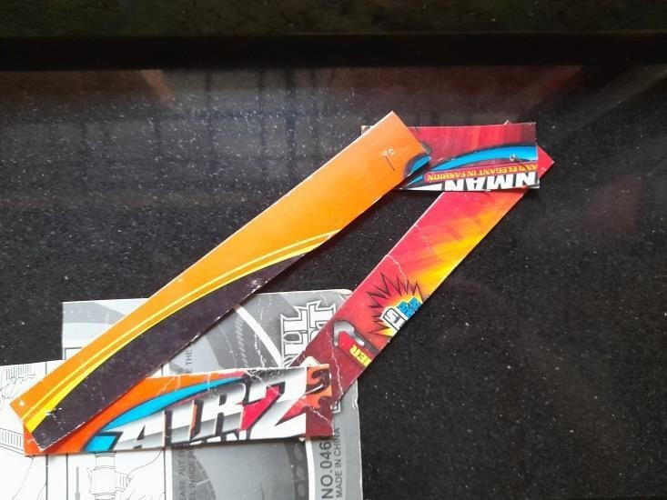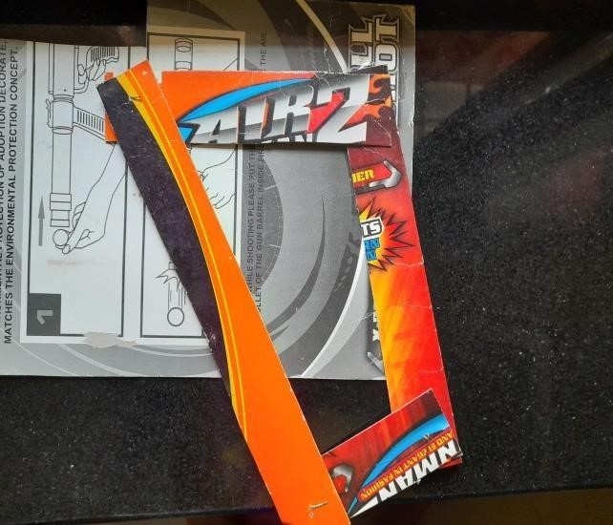

*Keeping the next link fixed*

*.*

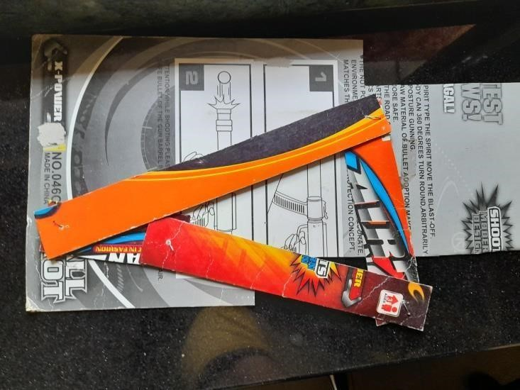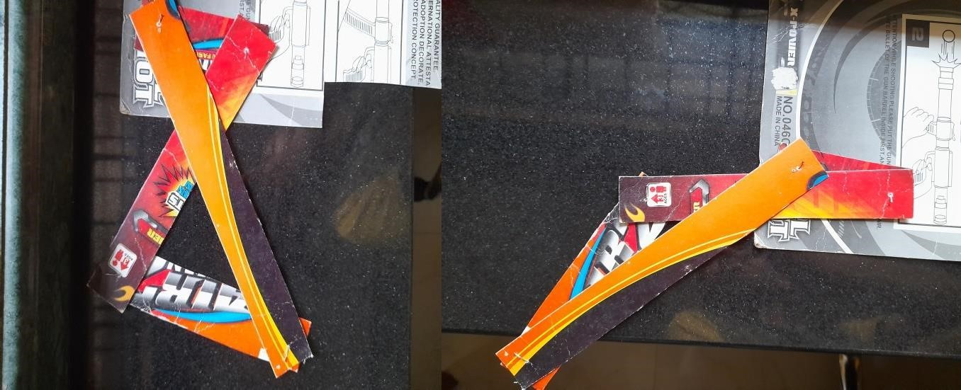

*Keeping the next link fixed*

